VTTI

SHRP 2 Safety Data – Naturalistic Driving Study Training Dataset

**DATA COLLECTION AND DATASET DESCRIPTION**

Prepared by

Yingfeng “Eric” Li, Ph.D., P.E.

Research Associate

540-231-8412

[eli@vtti.vt.edu](mailto:eli@vtti.vt.edu)

Jon Hankey, Ph.D.

Director for Research

540-231-1512

[jhankey@vtti.vt.edu](mailto:jhankey@vtti.vt.edu)

Miguel Perez

Director, Center for Data Reduction and Analysis Support

540-231-1537

[mperez@vtti.vt.edu](mailto:mperez@vtti.vt.edu)

Virginia Tech Transportation Institute

3500 Transportation Research Plaza, Blacksburg, VA 24061

February 2016

**TABLE OF CONTENTS**

INTRODUCTION 1

DATA COLLECTION 1

Data Collection Design 1

Data Collection Arrangements 2

DATA PROCESSING, FORMAT, AND SHARING 6

Training Dataset Contents 6

Data Checking Prior to Release 7

Data Sharing Requirements 7

APPENDIX A: PLANNED DATA COLLECTION ACTIVITIES 8

# INTRODUCTION

This document details the data collection effort that produced the downloadable training data set for the Second Strategic Highway Research Program (SHRP 2) Naturalistic Driving Study (NDS) data.

The training dataset contains video and kinematic data similar to the data that were collected in the SHRP 2 NDS dataset. However, because the training dataset was collected with VTTI staff (who agreed ahead of time to release their data freely into the public domain), it does not require the same mandatory Institutional Review Board (IRB) and SHRP 2 data sharing requirements as the actual SHRP 2 NDS data. The training dataset thus provides a “sandbox” that researchers can use for practice before requesting access to the actual SHRP 2 NDS data. Having a practice dataset helps researchers understand the driving-related variables that are available in the SHRP 2 NDS, including continuous sensor data, face video and GPS information. It is also hoped that this environment will allow potential users to better understand the content and structure of the NDS database in order to develop innovative uses of the SHRP 2 data.

# DATA COLLECTION

## Data Collection Design

**Data Acquisition System**. This data collection effort used the same onboard data acquisition systems (DASs) that were used in the actual SHRP 2 NDS to collect the same driver behavior, vehicle kinematic, and video data.

**Vehicles**. Three vehicles from the Virginia Tech Transportation Institute (VTTI) fleet were used for the data collection. These vehicles provided some information from the vehicle network, similar to many vehicles in the SHRP 2 NDS. Not all vehicles provided all vehicle network signals, but the mix of vehicles provides a fairly complete set.

**Drivers**. Three drivers were used as pseudo-participants during the data collection. The drivers were experienced employees of VTTI who had previously served as experimental vehicle drivers and had run instrumented-vehicle studies in the past. Before the data collection, drivers signed a form that gave permission for VTTI to provide the data to other researchers without data sharing or IRB requirements. The drivers reviewed and approved all video data before release.

During the data collection, drivers switched vehicles whenever possible to increase the number of driver/vehicle combinations. At each stop, a key-on and key-off cycle was included so researchers would be able to evaluate the impact that DAS start times and the time required to acquire a good Global Positioning System (GPS) signal could have on their potential research questions. Additional key-on and key-off cycles were included on longer routes to increase the total number of data collection trips and the trip diversity.

**Environmental Factors**. VTTI staff took advantage of naturally occurring environmental conditions during data collection. For example, there were multiple instances of rainy weather and some fog during the data collection period. In addition, data were collected during day, dusk, and night (with and without street lights) conditions.

**Staged Scenarios of Interest.** Since this was a limited data collection effort in which finding naturally occurring scenarios of interest was unlikely, several common events of interest were staged during the data collection to the extent possible when no vehicles from the general public could become involved. The staged scenarios included the following:

* Hard braking
* Short headway
* Low time to collision
* High lateral acceleration
* Vehicle cut-in
* Flying pass

Due to traffic conditions, such scenarios were mostly staged when traveling between VTTI headquarters in Blacksburg, Virginia, and Durham, North Carolina. These routes were relatively long and included roadway sections with light traffic, allowing sufficient and safe windows for staging the scenarios. **Note**: Certain driver behavior, such as speeding and in-vehicle cell phone use, were not simulated due to regulations pertinent to Virginia state vehicles.

**Data Collection Location and Roadway Environment**. The vehicles were driven from Blacksburg, Virginia, to Durham, North Carolina. Most data collection activities took place in and near Durham, an original NDS data collection site that is also included in the Roadway Information Database (RID). Routes were selected to maximize the number of roadways with detailed RID data (Figure 1) and the roads that were traversed by the most NDS trips (Figure 2).

## Data Collection Arrangements

Data collection was conducted between December 14 and 18, 2015. Appendix A includes a detailed list of data collection activities and routes by date and time. At each planned stop, the drivers completely turned off each vehicle so that a new data collection trip could start. During the stages to and from North Carolina, drivers switched vehicles at each stop to ensure that all drivers drove all vehicles. At the North Carolina data collection site, the drivers also switched vehicles after each data collection period. Users should note that the actual data collection routes were slightly different from the planned routes due to traffic and conditions that were not foreseen.

As shown in Appendix A, the planned data collection included about 100 trips and more than 2,500 vehicle miles. During the entire data collection week, the data collection systems were turned on whenever the vehicles were turned on, allowing additional data to be collected from unscheduled activities, such as driving to/from meals or refilling gas. A total of 131 different data collection trips were collected. Since the driving environment could result in “noisy” data (e.g., missing GPS coordinates in urban canyons), routes were chosen so that examples of different types of “noisy” data might be included.

The availability of RID data was used as a basis to select routes. In addition, recognizing that it was not feasible to simulate all roadway, traffic, and weather combinations available in the current SHRP 2 data, the routes were selected by taking the following factors into consideration to maximize the variety of data collected:

* *Roadway type*. The routes included a large variety of roadways, including freeways, major arterials, and collectors in urban and rural areas with different numbers of travel lanes.
* *Trip origins/destinations*. A wide range of origins and destinations were included in the data collection, such as shopping centers and various types of stores, residential neighborhoods, schools, airports, governmental agencies, restaurants, and hotels.
* *Intersections*. Detailed data for a roundabout, conventional intersections, and an interchange were collected by traversing them from all directions during both the daytime and nighttime.
* *Traffic conditions*. The data collection effort included both non-peak hours and morning and afternoon peak hours. Data were collected in both rural areas with light traffic and the central business district/downtown areas of cities such as Raleigh and Durham where significant traffic and pedestrian traffic was present.
* *Presence of pedestrians*. Urban settings were included to ensure data collection that included the presence of pedestrians and cyclists, and potential interactions with these roadway users.
* *Trip lengths*. The data collection trips ranged from a few miles to tens of miles in length.

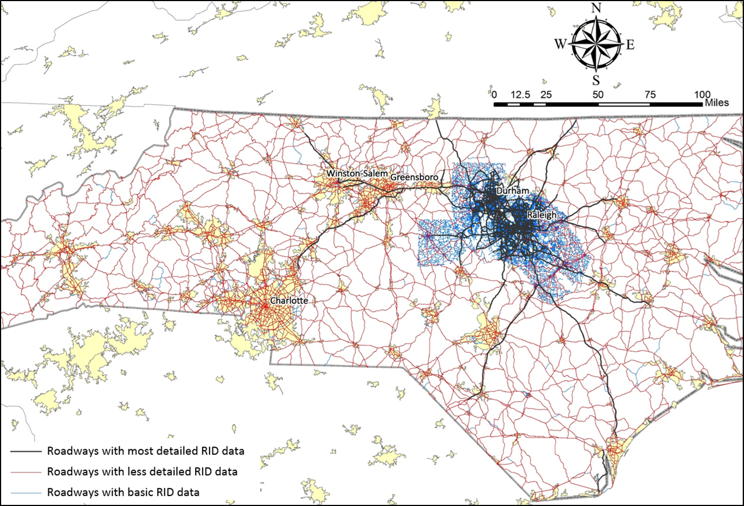

Figure 1: RID Data Coverage for North Carolina.

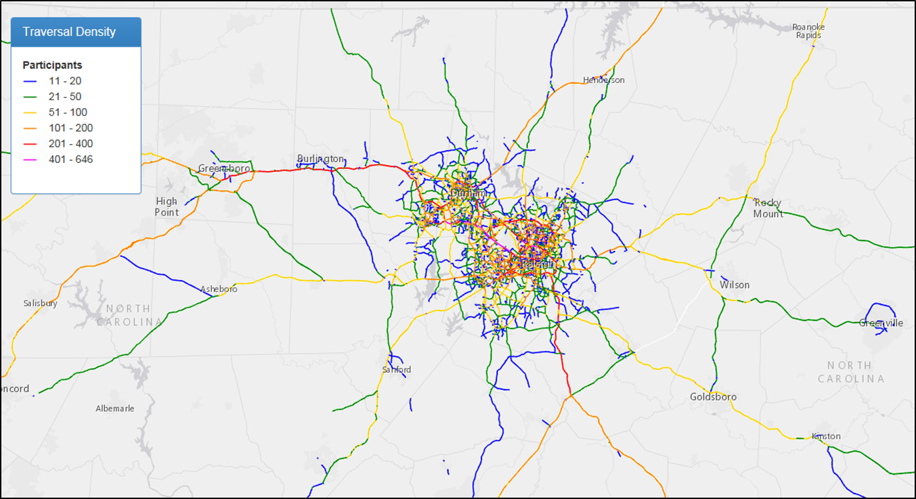

Figure 2: SHRP 2 NDS Trip Density for North Carolina.

# DATA PROCESSING, FORMAT, AND SHARING

## Training Dataset Contents

This data collection effort focused on the same vehicle and sensor data (i.e., time series data) collected during the SHRP 2 NDS. Table 1 lists the variables that were collected. A detailed description of each variable is available in the metadata documentation associated with the actual SHRP 2 NDS data.

Table 1: NDS Data Variables Collected in the Training Dataset.

|  |  |  |
| --- | --- | --- |
| ABS Activation | Head Rotation Y Baseline | Radar, Target Identification – 8 Tracks |
| Acceleration, x-axis | Head Rotation Z | Radar, Is Lead Vehicle – 8 Tracks |
| Acceleration, x-axis fast | Head Rotation Z Baseline | Radar, Relative Accel X – 8 Tracks |
| Acceleration, y-axis | Heading, GPS | Radar, Lane – 8 Tracks |
| Acceleration, y-axis fast | Headlight Setting | Radar, Travel Direction – 8 Tracks |
| Acceleration, z-axis | Illuminance, Ambient | Radar, Headway – 8 Tracks |
| Acceleration, z-axis fast | Lane Marking, Distance, Left | Roll Rate, x-axis |
| Airbag, Driver | Lane Marking, Distance, Right | Roll Rate, x-axis fast |
| Alcohol | Lane Marking, Probability, Right | Seatbelt, Driver |
| Cruise Control | Lane Marking, Type, Left | Speed, GPS |
| Day of Week | Lane Marking, Type, Right | Speed, Vehicle Network |
| Dilution of Precision, Position | Lane Markings, Probability, Left | Steering Wheel Position |
| Distance | Lane Position Offset | Driver_ID |
| Driver Button Flag | Lane Width | Temperature, Interior |
| Electronic Stability Control | Latitude | Timestamp |
| Elevation, GPS | Longitude | Traction Control |
| Engine RPM | Month | Turn Signal |
| Head Confidence | Number of Satellites | Vehicle_ID |
| Head Position X | Pedal, Accelerator Position | Video Dashboard and Steering Wheel View |
| Head Position X Baseline | Pedal, Brake | Video Frame Number |
| Head Position Y | Pitch Rate, y-axis | Video, Driver and Left Side View |
| Head Position Y Baseline | Pitch Rate, y-axis fast | Video, Forward Roadway |
| Head Position Z | PRNDL | Video, Rear View |
| Head Position Z Baseline | Radar, Range Rate Forward X – 8 Tracks | Wiper Setting |
| Head Rotation X | Radar, Range Rate Forward Y – 8 Tracks | Yaw Rate, z-axis |
| Head Rotation X Baseline | Radar, Range, Forward X – 8 Tracks | Yaw Rate, z-axis fast |
| Head Rotation Y | Radar, Range, Forward Y – 8 Tracks | Year |

The training dataset also includes the map matching table that can be used to link the NDS data with locations from the RID. Because the practice dataset is not subject to the same restrictions placed on personally identifying information (PII) as the SHRP 2 NDS, which requires removing origins and destinations, Link IDs for the full trips are available. Other primary sources of data that researchers would use, such as driver and vehicle information, are already available on the InSight website at no cost and therefore were not included in this training dataset. Similarly, the RID can be obtained currently from the Center for Transportation Research and Education (CTRE) at a nominal charge.

The training dataset was processed using the same procedures that were used for the SHRP 2 NDS:

* Videos were processed and separated into individual video streams.
* Vehicle network information was extracted and put into a common format across vehicles.
* Radar data were post-processed to clean up the data streams and add some key variables (e.g., headway).
* The naturalistic data were matched to the same map on which the RID was based.

Interested researchers are able to download the data in the same format that was provided to the Implementation Assistance Projects (IAPs), which has been the most commonly requested format for researchers acquiring actual NDS data under a Data Use License (DUL). The parametric data from the vehicle are provided in a 10-Hz synchronized format. The video data are provided with each individual camera view separated and processed in the same manner as the SHRP 2 data.

## Data Checking Prior to Release

The same quality control procedures used in SHRP 2 were used for the training dataset. In addition, all the video files were reviewed to ensure that no videos with sensitive content would be unintentionally released. The VTTI employees who drove the vehicles reviewed their own video data to ensure that they were fully comfortable with all the videos that are released. Any trips that drivers were uncomfortable with were expunged from the data.

## Data Sharing Requirements

Because the dataset does not contain human subject data, no IRB approval or data sharing agreement is required. Qualified users are able to access the data from the InSight website by clicking on the data link and accepting a Creative Commons 4.0 license.

# APPENDIX A: DATA COLLECTION ACTIVITIES

This section includes the originally planned data collection activities that the VTTI drivers used as the guide for their data collection. Actual data available in the training dataset may vary slightly due to unforeseeable conditions.

**Monday, December 14.** This data collection effort was intended to collect a total of 855 vehicle miles of data on Monday in about 30 trips based on the data collection plan.

* 8:00 a.m. – 12:00 p.m. (Table 2 and Figure 3): Travel from Blacksburg, Virginia, to Durham, North Carolina (freeway route). The three vehicles accompanied each other and staged the scenarios of interest to the extent possible after they crossed the state line. When stopped to switch drivers, the vehicles were turned off so that a new data collection trip could start.

Table 2: List of Data Collection Trips for 12/14 Morning.

|  |  |  |  |  |  |
| --- | --- | --- | --- | --- | --- |
| **No.** | **From** | **To** | **Driver** | **Vehicle** | **Mileage** |
| 1 | Blacksburg | Rural Hall, NC (SH 65) | A | V1 | 116 |
| 2 | Blacksburg | Rural Hall, NC (SH 65) | B | V2 | 116 |
| 3 | Blacksburg | Rural Hall, NC (SH 65) | C | V3 | 116 |
| 4 | Rural Hall, NC (SH 65) | Burlington, NC | B | V1 | 57 |
| 5 | Rural Hall, NC (SH 65) | Burlington, NC | C | V2 | 57 |
| 6 | Rural Hall, NC (SH 65) | Burlington, NC | A | V3 | 57 |
| 7 | Burlington, NC | Durham, NC | C | V1 | 35 |
| 8 | Burlington, NC | Durham, NC | A | V2 | 35 |
| 9 | Burlington, NC | Durham, NC | B | V3 | 35 |
| **Total Vehicle Miles (including Virginia portion)** | | | | | 624 |

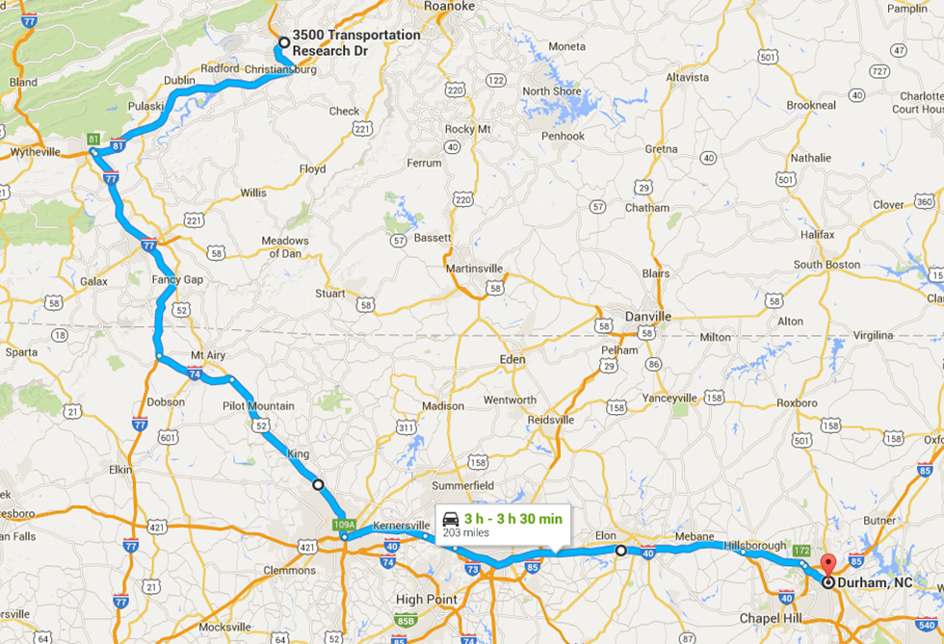

Figure 3: Route Map for 12/14 Morning.

* 1:00 p.m. – 5:00 p.m. (Table 3, Figure 4, Figure 5, and Figure 6): Data collection in the Durham-Raleigh region, including a total of 231 planned vehicle miles and 12 trips.

Table 3: Data Collection Arrangements for Monday Afternoon (231 Vehicle Miles).

|  |  |  |  |
| --- | --- | --- | --- |
| **No.** | **From/To** | **Mileage** | **Note** |
| **Driver A, Vehicle 1, 81 miles (Figure 4)** | | | |
| 1 | Holiday Inn Express  2516 Guess Rd, Durham, NC 27705 | 24 |  |
| 2 | Walmart  973 N Harrison Ave, Cary, NC 27513 | 25 |  |
| 3 | Triangle Town Center  5959 Triangle Town Blvd, Raleigh, NC 27616 | 9 |  |
| 4 | Brassfield Elementary School  2001 Brassfield Rd, Raleigh, NC 27614 | 23 |  |
| 5 | Holiday Inn Express  2516 Guess Rd, Durham, NC 27705 |  | Stay overnight in Holiday Inn Express, Durham. |
| **Driver B, Vehicle 2, 68 miles (Figure 5)** | | | |
| 6 | Holiday Inn Express  2516 Guess Rd, Durham, NC 27705 | 26 |  |
| 7 | Starbucks  6176 Falls of Neuse Rd, Raleigh, NC 27609 | 15 |  |
| 8 | Walmart  973 N Harrison Ave, Cary, NC 27513 | 8 |  |
| 9 | Raleigh-Durham International Airport  2400 John Brantley Blvd, Morrisville, NC 27560 | 19 |  |
| 10 | Holiday Inn Express  2516 Guess Rd, Durham, NC 27705 |  | Stay overnight in Holiday Inn Express, Durham. |
| **Driver C, Vehicle 3, 82 miles (Figure 6)** | | | |
| 11 | Holiday Inn Express  2516 Guess Rd, Durham, NC 27705 | 28 |  |
| 12 | Anytime Fitness  3607 Falls River Ave Ste 111, Raleigh, NC 27614 | 25 |  |
| 13 | Walmart  973 N Harrison Ave, Cary, NC 27513 | 15 |  |
| 14 | Macy's  6910 Fayetteville Rd suite 300, Durham, NC 27713 | 14 |  |
| 15 | Holiday Inn Express  2516 Guess Rd, Durham, NC 27705 |  | Stay overnight in Holiday Inn Express, Durham. |
| An estimated minimum of 231 vehicle miles and 12 data collection trips. | | | |

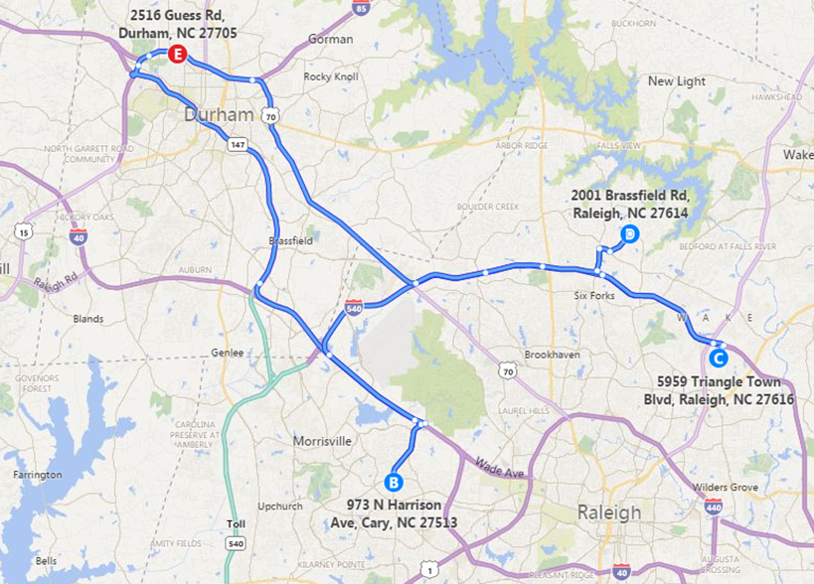

Figure 4: Route Map (Driver A, Vehicle 1, Monday Afternoon).

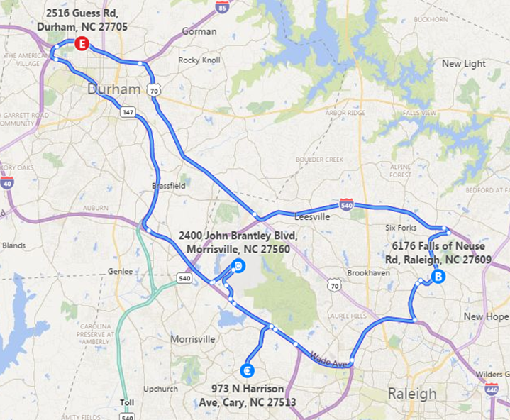

Figure 5: Route Map (Driver B, Vehicle 2, Monday Afternoon).

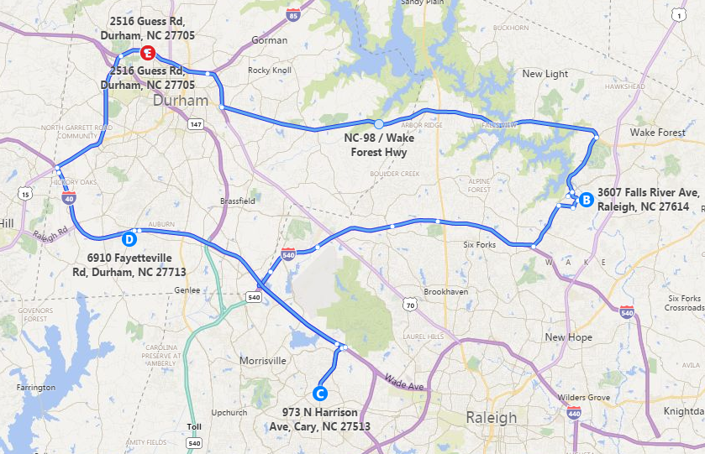

Figure 6: Route Map (Driver C, Vehicle 3, Monday Afternoon).

**Tuesday, December 15.** This data collection effort was intended to collect data for a total of 658 vehicle miles in the Durham-Raleigh region in 37 trips, including data for a roundabout, three intersections, and an interchange.

* 6:30 a.m. – 11:30 a.m. (Table 4, Figure 7, Figure 8, and Figure 9): Data for a total of 251 vehicle miles in 15 trips was collected, including data for a roundabout, three intersections, and an interchange.

Table 4: Data Collection Arrangements for Tuesday Morning (251 Vehicle Miles).

|  |  |  |  |
| --- | --- | --- | --- |
| **No.** | **From/To** | **Mileage** | **Note** |
| **Driver A, Vehicle 3, 95 miles (Figure 7)** | | | |
| 1 | Holiday Inn Express  2516 Guess Rd, Durham, NC 27705 | 29 |  |
| 2 | DoubleTree by Hilton  1707 Hillsborough St, Raleigh, NC 27605 | 9 | Traverse all legs of roundabout at Hillsborough St./Pullen Rd. |
| 3 | Walmart  4431 New Bern Ave, Raleigh, NC 27610 | 14 | Traverse all legs of intersection at I-64 Business/N New Hope Rd. |
| 4 | Kroger  7905 Falls of Neuse Rd, Raleigh, NC 27615 | 14 |  |
| 5 | Holiday Inn Express  2516 Guess Rd, Durham, NC 27705 | 29 |  |
| 6 | Hampton Inn & Suites  111 Hampton Woods Ln, Raleigh, NC 27607 |  |  |
| **Driver B, Vehicle 1, 78 miles (Figure 8)** | | | |
| 7 | Holiday Inn Express  2516 Guess Rd, Durham, NC 27705 | 24 |  |
| 8 | Kroger  7905 Falls of Neuse Rd, Raleigh, NC 27615 | 8 |  |
| 9 | Sycamore Creek Elementary School  10921 Leesville Rd, Raleigh, NC 27613 | 9 |  |
| 10 | Sheraton Imperial Hotel & Convention Center  4700 Emperor Blvd, Durham, NC 27703 | 22 | Traverse all ramps of interchange at I‑540/I‑40 |
| 11 | Walmart  4431 New Bern Ave, Raleigh, NC 27610 | 15 | Traverse all legs of intersection at I-64 Business/N New Hope Rd. |
| 12 | Hampton Inn & Suites  111 Hampton Woods Ln, Raleigh, NC 27607 |  |  |
| **Driver C, Vehicle 2, 78 miles (Figure 9)** | | | |
| 13 | Holiday Inn Express  2516 Guess Rd, Durham, NC 27705 | 12 |  |
| 14 | Starbucks  103 E Franklin St, Chapel Hill, NC 27514 | 11 |  |
| 15 | Bojangles' Famous Chicken 'n Biscuits  4831 NC-55, Research Triangle Park, NC 27713 | 23 | Traverse all legs of intersection at NC‑54/NC-55 |
| 16 | Residential neighborhood  2312 Falls River Ave, Raleigh, NC 27614 | 17 |  |
| 17 | Walmart  4431 New Bern Ave, Raleigh, NC 27610 | 15 |  |
| 18 | Hampton Inn & Suites  111 Hampton Woods Ln, Raleigh, NC 27607 |  |  |
| An estimated minimum of 251 vehicle miles of and 15 data collection trips. | | | |

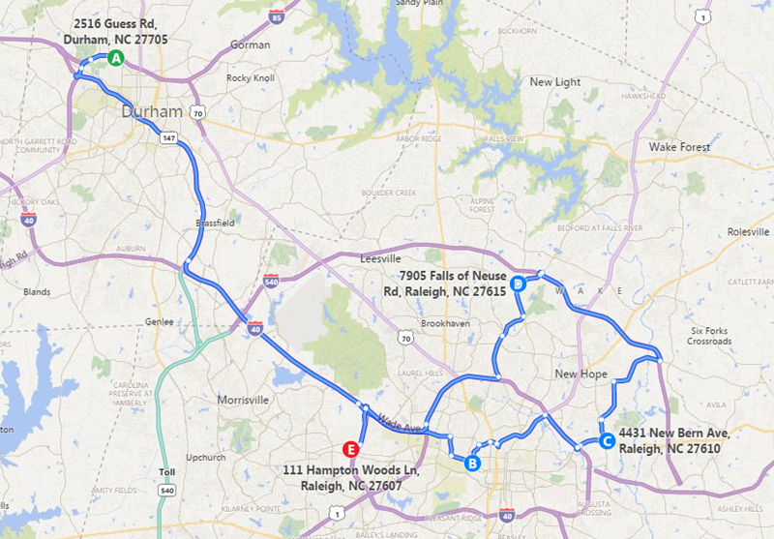

Figure 7: Route Map (Driver A, Vehicle 3, Tuesday Morning).

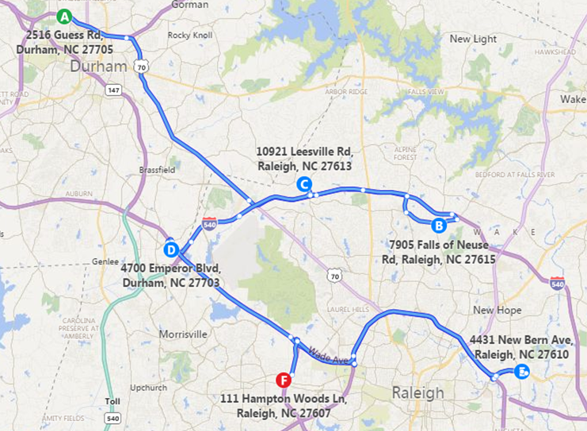

Figure 8: Route Map (Driver B, Vehicle 1, Tuesday Morning).

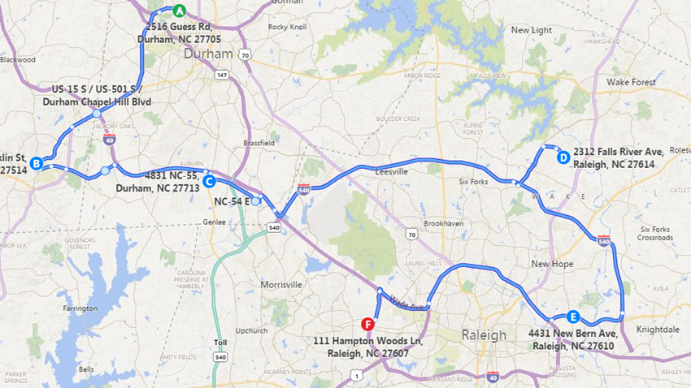

Figure 9: Route Map (Driver C, Vehicle 2, Tuesday Morning).

* 1:00 p.m. – 4:00 p.m. (Table 5, Figure 10, Figure 11, and Figure 12): A total of about 230 vehicle miles in 13 trips.

Table 5: Data Collection Arrangements for Tuesday Afternoon (228 Vehicle Miles).

|  |  |  |  |
| --- | --- | --- | --- |
| **No.** | **From/To** | **Mileage** | **Note** |
| **Driver A, Vehicle 2, 78 miles (Figure 10)** | | | |
| 1 | Hampton Inn & Suites  111 Hampton Woods Ln, Raleigh, NC 27607 | 11 |  |
| 2 | North Carolina State Bar  217 E Edenton St, Raleigh, NC 27601 | 11 |  |
| 3 | Kroger  7905 Falls of Neuse Rd, Raleigh, NC 27615 | 20 |  |
| 4 | CVS Pharmacy  612 N Main St, Creedmoor, NC 27522 | 14 |  |
| 5 | Harbor Freight Tools  2000 Avondale Dr, Durham, NC 27704 | 21 |  |
| 6 | Hampton Inn & Suites  111 Hampton Woods Ln, Raleigh, NC 27607 |  | Stay overnight at Hampton Inn & Suites, Raleigh |
| **Driver B, Vehicle 3, 78 miles (Figure 11)** | | | |
| 7 | Hampton Inn & Suites  111 Hampton Woods Ln, Raleigh, NC 27607 | 22 |  |
| 8 | Harbor Freight Tools  2000 Avondale Dr, Durham, NC 27704 | 31 |  |
| 9 | North Carolina State Bar  217 E Edenton St, Raleigh, NC 27601 | 11 |  |
| 10 | Kroger  7905 Falls of Neuse Rd, Raleigh, NC 27615 | 14 |  |
| 11 | Hampton Inn & Suites  111 Hampton Woods Ln, Raleigh, NC 27607 |  | Stay overnight at Hampton Inn & Suites, Raleigh |
| **Driver C, Vehicle 1, 75 miles (Figure 12)** | | | |
| 12 | Hampton Inn & Suites  111 Hampton Woods Ln, Raleigh, NC 27607 | 26 |  |
| 13 | Staples  11845 Retail Dr, Wake Forest, NC 27587 | 19 |  |
| 14 | Food Lion  2400 Holloway Dr, Durham, NC 27703 | 21 |  |
| 15 | Tropical Smoothie Café  1028 Oberlin Rd #232, Raleigh, NC 27605 | 9 |  |
| 16 | Hampton Inn & Suites  111 Hampton Woods Ln, Raleigh, NC 27607 |  | Stay overnight at Hampton Inn & Suites, Raleigh |
| An estimated minimum vehicle miles of 231 and 13 data collection trips. | | | |

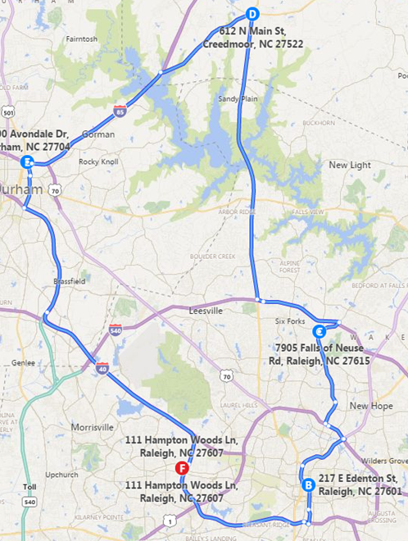

Figure 10: Route Map (Driver A, Vehicle 2, Tuesday Afternoon).

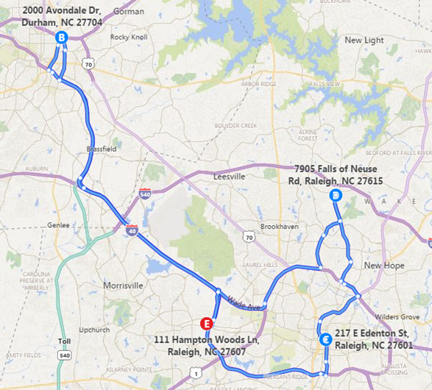

Figure 11: Route Map (Driver B, Vehicle 3, Tuesday Afternoon).

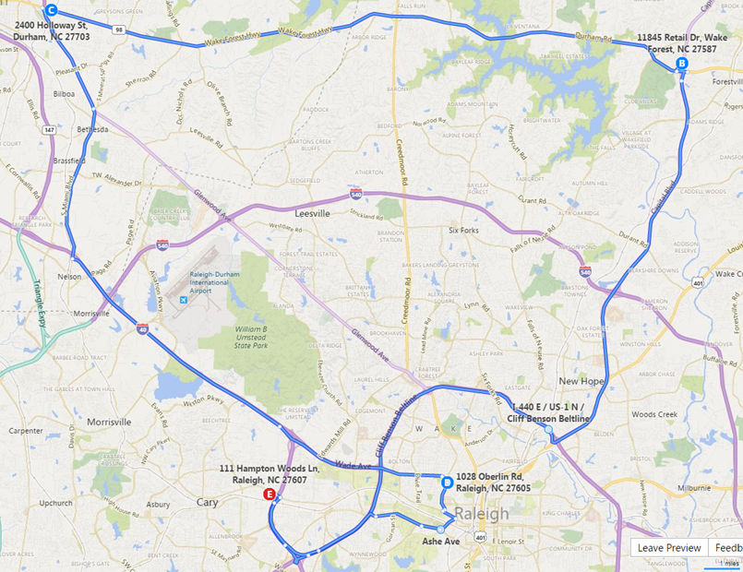

Figure 12: Route Map (Driver C, Vehicle 1, Tuesday Afternoon).

* 5:00 – 8:00 PM (Table 6, Figure 13, Figure 14, and Figure 15): A total of 177 vehicle miles in nine trips.

Table 6: Data Collection Arrangements for Tuesday Evening (177 Vehicle Miles).

|  |  |  |  |
| --- | --- | --- | --- |
| **No.** | **From/To** | **Mileage** | **Note** |
| **Driver A, Vehicle 1, 63 miles (Figure 13)** | | | |
| 1 | Hampton Inn & Suites  111 Hampton Woods Ln, Raleigh, NC 27607 | 26 |  |
| 2 | Staples  11845 Retail Dr, Wake Forest, NC 27587 | 19 |  |
| 3 | Food Lion  2400 Holloway Dr, Durham, NC 27703 | 18 |  |
| 4 | Hampton Inn & Suites  111 Hampton Woods Ln, Raleigh, NC 27607 |  | Stay overnight at Hampton Inn & Suites, Raleigh |
| **Driver B, Vehicle 2, 51 miles (Figure 14)** | | | |
| 5 | Hampton Inn & Suites  111 Hampton Woods Ln, Raleigh, NC 27607 | 11 |  |
| 6 | North Carolina State Bar  217 E Edenton St, Raleigh, NC 27601 | 21 |  |
| 7 | Food Lion  2400 Holloway Dr, Durham, NC 27703 | 19 |  |
| 8 | Hampton Inn & Suites  111 Hampton Woods Ln, Raleigh, NC 27607 |  | Stay overnight at Hampton Inn & Suites, Raleigh |
| **Driver C, Vehicle 3, 63 miles (Figure 15)** | | | |
| 9 | Hampton Inn & Suites  111 Hampton Woods Ln, Raleigh, NC 27607 | 21 |  |
| 10 | One Restaurant  100 Meadowmont Village Cir, Chapel Hill, NC 27517 | 14 |  |
| 11 | Holiday Inn Express  2516 Guess Rd, Durham, NC 27705 | 28 |  |
| 12 | Hampton Inn & Suites  111 Hampton Woods Ln, Raleigh, NC 27607 |  | Stay overnight at Hampton Inn & Suites, Raleigh |
| An estimated minimum of 177 vehicle miles and nine data collection trips. | | | |

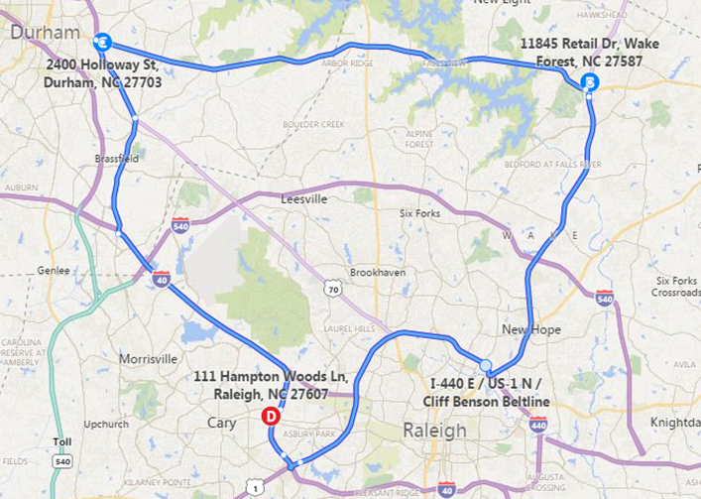

Figure 13: Route Map (Driver A, Vehicle 1, Tuesday Evening).

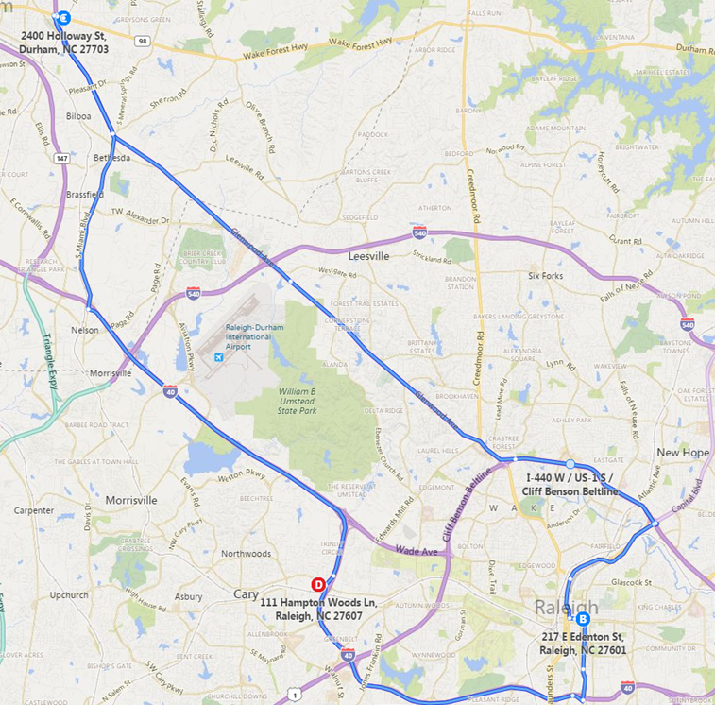

Figure 14: Route Map (Driver B, Vehicle 2, Tuesday Evening).

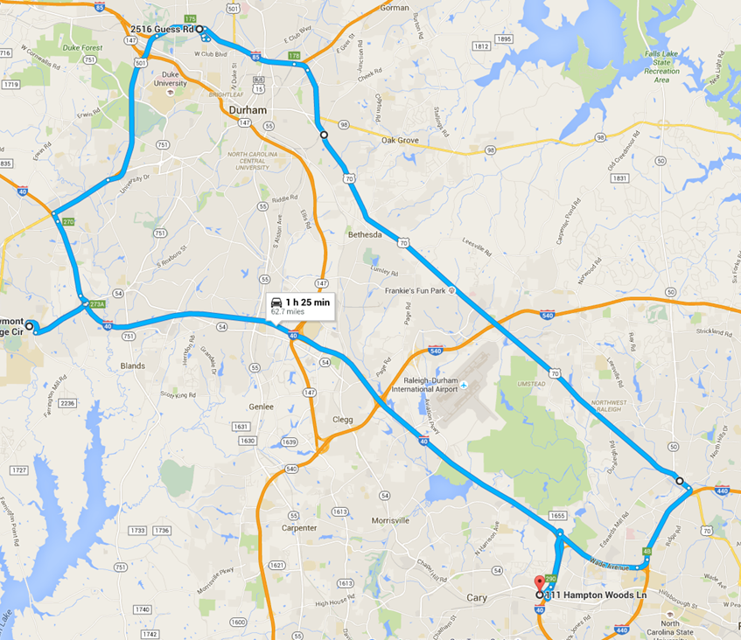

Figure 15: Route Map (Driver C, Vehicle 3, Tuesday Evening).

**Wednesday, December 16.** This data collection effort was intended to collect data for a total of approximately 500 vehicle miles during Wednesday afternoon and night. Nighttime data for a roundabout, three intersections, and an interchange were collected as well.

* 1:00 p.m. – 5:00 p.m. (Table 7, Figure 16, Figure 17, and Figure 18): Data for a total of 331 vehicle miles in 16 planned trips.

Table 7: Data Collection Arrangements for Wednesday Afternoon (331 Vehicle Miles).

|  |  |  |  |
| --- | --- | --- | --- |
| **No.** | **From/To** | **Mileage** | **Note** |
| **Driver A, Vehicle 3, 146 miles (Figure 16)** | | | |
| 1 | Hampton Inn & Suites  111 Hampton Woods Ln, Raleigh, NC 27607 | 26 |  |
| 2 | Residential neighborhood  2312 Falls River Ave, Raleigh, NC 27614 | 26 |  |
| 3 | Hampton Inn & Suites  111 Hampton Woods Ln, Raleigh, NC 27607 | 30 |  |
| 4 | Staples  11845 Retail Dr, Wake Forest, NC 27587 | 22 |  |
| 5 | Hampton Inn & Suites  111 Hampton Woods Ln, Raleigh, NC 27607 | 21 |  |
| 6 | Harbor Freight Tools  2000 Avondale Dr, Durham, NC 27704 | 21 |  |
| 7 | Hampton Inn & Suites  111 Hampton Woods Ln, Raleigh, NC 27607 |  | Stay overnight at Hampton Inn & Suites, Raleigh |
| **Driver B, Vehicle 1, 96 miles (Figure 17)** | | | |
| 8 | Hampton Inn & Suites  111 Hampton Woods Ln, Raleigh, NC 27607 | 44 |  |
| 9 | CVS Pharmacy  612 N Main St, Creedmoor, NC 27522 | 29 |  |
| 10 | Starbucks  103 E Franklin St, Chapel Hill, NC 27514 | 23 |  |
| 11 | Hampton Inn & Suites  111 Hampton Woods Ln, Raleigh, NC 27607 |  | Stay overnight at Hampton Inn & Suites, Raleigh |
| **Driver C, Vehicle 2, 89 miles (Figure 18)** | | | |
| 12 | Hampton Inn & Suites  111 Hampton Woods Ln, Raleigh, NC 27607 | 17 |  |
| 13 | Triangle Town Center  5959 Triangle Town Boulevard, Raleigh, NC 27616 | 8 |  |
| 14 | North Hills  4321 Lassiter Mill Rd, Raleigh, NC 27609 | 7 |  |
| 15 | Kimberly A. Cook, RPH  8821 State Road 3359, Raleigh, NC 27615 | 11 |  |
| 16 | Raleigh-Durham International Airport  2400 John Brantley Boulevard, Morrisville, NC 27560 | 7 |  |
| 17 | Park West Village  Village Market Place, Morrisville, NC 27560 | 19 |  |
| 18 | One Restaurant  100 Meadowmont Village Circle, Chapel Hill, NC 27517 | 20 |  |
| 19 | Hampton Inn & Suites  111 Hampton Woods Ln, Raleigh, NC 27607 |  | Stay overnight at Hampton Inn & Suites, Raleigh |
| An estimated minimum of 331 vehicle miles and 16 data collection trips. | | | |

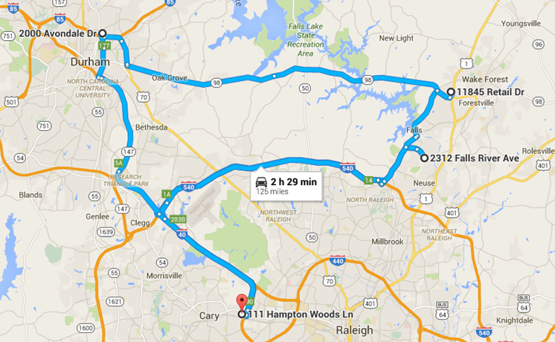

Figure 16: Route Map (Driver A, Vehicle 3, Wednesday Afternoon).

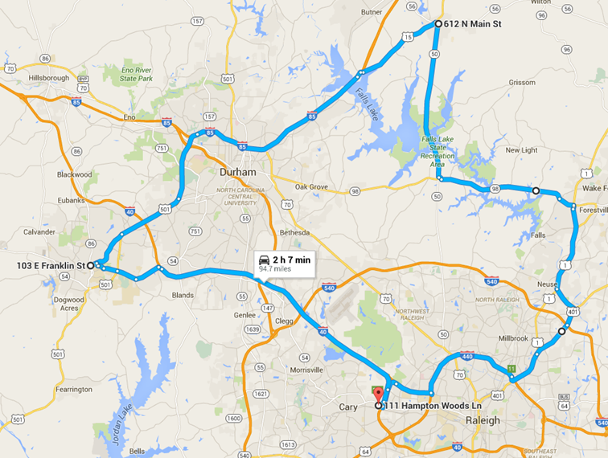

Figure 17: Route Map (Driver B, Vehicle 1, Wednesday Afternoon).

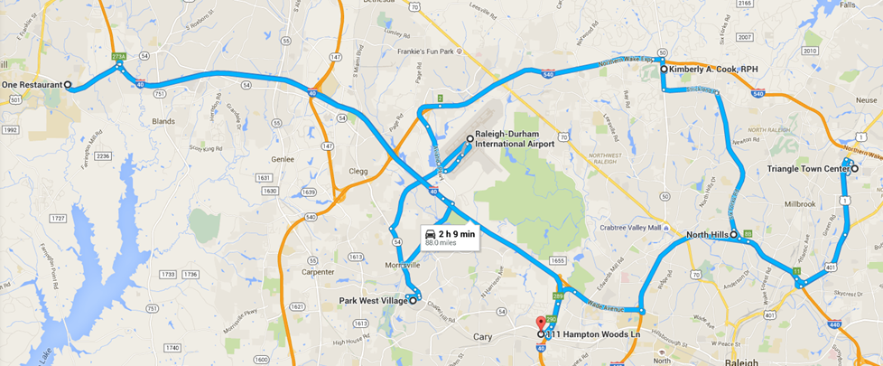

Figure 18: Route Map (Driver C, Vehicle 2, Wednesday Afternoon).

* 7:00 p.m. – 10:30 p.m. (Table 8, Figure 19, Figure 20, and Figure 21): Nighttime data for a total of 189 vehicle miles in 13 trips, including data for a roundabout, three intersections, and an interchange.

Table 8: Data Collection Arrangements for Wednesday Night (189 Vehicle Miles).

|  |  |  |  |
| --- | --- | --- | --- |
| **No.** | **From/To** | **Mileage** | **Note** |
| **Driver A, Vehicle 2, 38 miles (Figure 19)** | | | |
| 1 | Hampton Inn & Suites  111 Hampton Woods Ln, Raleigh, NC 27607 | 6 |  |
| 2 | DoubleTree by Hilton  1707 Hillsborough St, Raleigh, NC 27605 | 7 | Traverse all legs of roundabout at Hillsborough St./Pullen Rd. |
| 3 | Walmart  4431 New Bern Ave, Raleigh, NC 27610 | 11 | Traverse all legs of intersection at I-64 Business/N New Hope Rd. |
| 4 | Kroger  7905 Falls of Neuse Rd, Raleigh, NC 27615 | 14 |  |
| 5 | Hampton Inn & Suites  111 Hampton Woods Ln, Raleigh, NC 27607 |  | Stay overnight at Hampton Inn & Suites, Raleigh |
| **Driver B, Vehicle 3, 69 miles (Figure 20)** | | | |
| 6 | Hampton Inn & Suites  111 Hampton Woods Ln, Raleigh, NC 27607 | 14 |  |
| 7 | Kroger  7905 Falls of Neuse Rd, Raleigh, NC 27615 | 8 |  |
| 8 | Sycamore Creek Elementary School  10921 Leesville Rd, Raleigh, NC 27613 | 9 |  |
| 9 | Sheraton Imperial Hotel & Convention Center  4700 Emperor Blvd, Durham, NC 27703 | 22 | Traverse all ramps of interchange at I‑540/I-40. |
| 10 | Walmart  4431 New Bern Ave, Raleigh, NC 27610 | 16 | Traverse all legs of intersection at I-64 Business/N New Hope Rd. |
| 11 | Hampton Inn & Suites  111 Hampton Woods Ln, Raleigh, NC 27607 |  | Stay overnight at Hampton Inn & Suites, Raleigh |
| **Driver C, Vehicle 1, 82 miles (Figure 21)** | | | |
| 12 | Hampton Inn & Suites  111 Hampton Woods Ln, Raleigh, NC 27607 | 23 |  |
| 13 | Starbucks  103 E Franklin St, Chapel Hill, NC 27514 | 10 |  |
| 14 | Bojangles' Famous Chicken 'n Biscuits  4831 NC-55, Research Triangle Park, NC 27713 | 23 | Traverse all legs of intersection at NC‑54/NC-55. |
| 15 | Residential neighborhood  2312 Falls River Ave, Raleigh, NC 27614 | 26 |  |
| 16 | Hampton Inn & Suites  111 Hampton Woods Ln, Raleigh, NC 27607 |  | Stay overnight at Hampton Inn & Suites, Raleigh |
| An estimated minimum of 189 vehicle miles and 13 data collection trips. | | | |

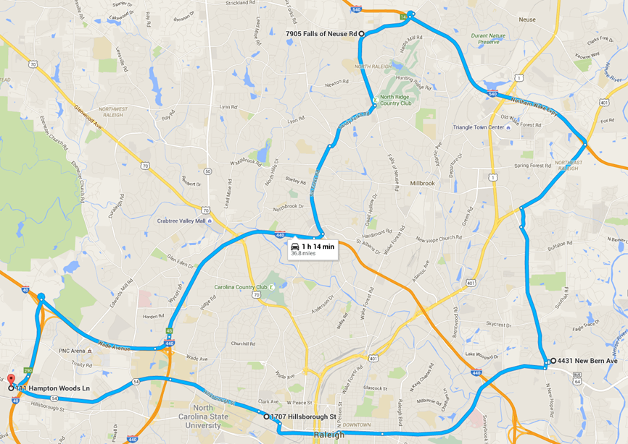

Figure 19: Route Map (Driver A, Vehicle 2, Wednesday Night).

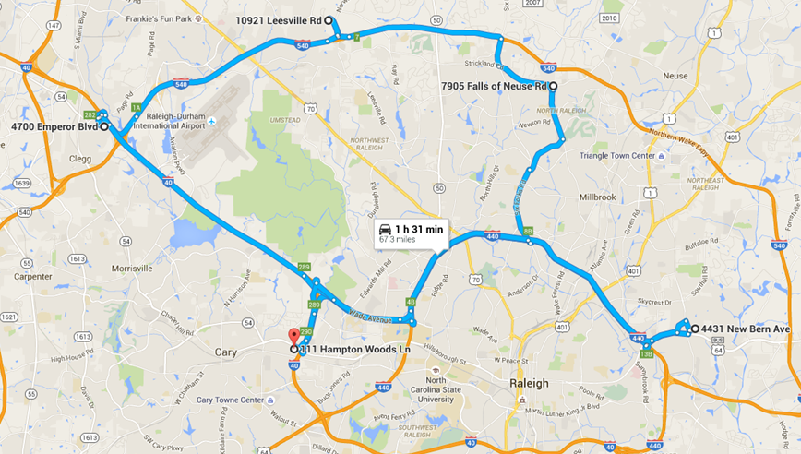

Figure 20: Route Map (Driver B, Vehicle 3, Wednesday Night).

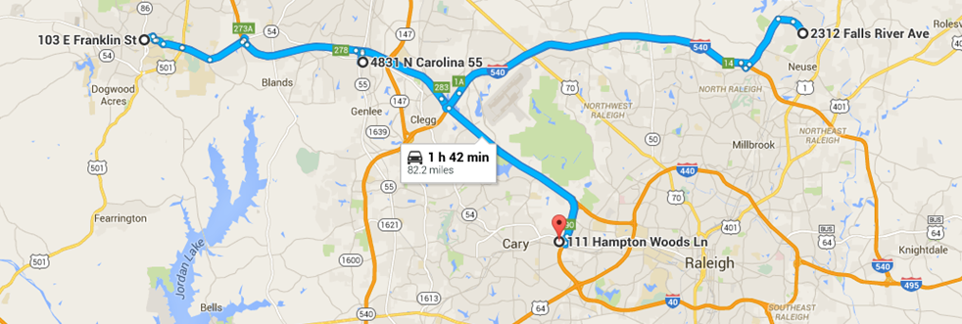

Figure 21: Route Map (Driver C, Vehicle 1, Wednesday Night).

**Thursday, December 17.** Thedata collection team traveled back to VTTI headquarters on Thursday, December 17. During this return trip, the team took a different route that consisted of mostly state and local roads. Data for a total of 555 vehicle miles was collected in nine trips. During each stop, the vehicles were turned off completely and drivers switched vehicles. During these trips, the three vehicles accompanied each other and staged the scenarios of interest to the extent possible within North Carolina. When stopped to switch drivers, the vehicles were turned off so that a new data collection trip could start.

* Driving back (Table 9 and Figure 22): A total of 555 vehicle miles in nine trips.

Table 9: List of Data Collection Trips for 12/17 Morning (555 Vehicle Miles).

|  |  |  |  |  |  |
| --- | --- | --- | --- | --- | --- |
| **No.** | **From** | **To** | **Driver** | **Vehicle** | **Mileage** |
| 1 | Raleigh | Chapel Hill, NC | B | V1 | 22 |
| 2 | Raleigh | Chapel Hill, NC | C | V2 | 22 |
| 3 | Raleigh | Chapel Hill, NC | A | V3 | 22 |
| 4 | Chapel Hill, NC | Reidsville, NC | B | V1 | 57 |
| 5 | Chapel Hill, NC | Reidsville, NC | C | V2 | 57 |
| 6 | Chapel Hill, NC | Reidsville, NC | A | V3 | 57 |
| 7 | Reidsville, NC | Blacksburg, VA | B | V1 | 106 |
| 8 | Reidsville, NC | Blacksburg, VA | C | V2 | 106 |
| 9 | Reidsville, NC | Blacksburg, VA | A | V3 | 106 |
| **Total Vehicle Miles (including Virginia portion)** | | | | | 555 |

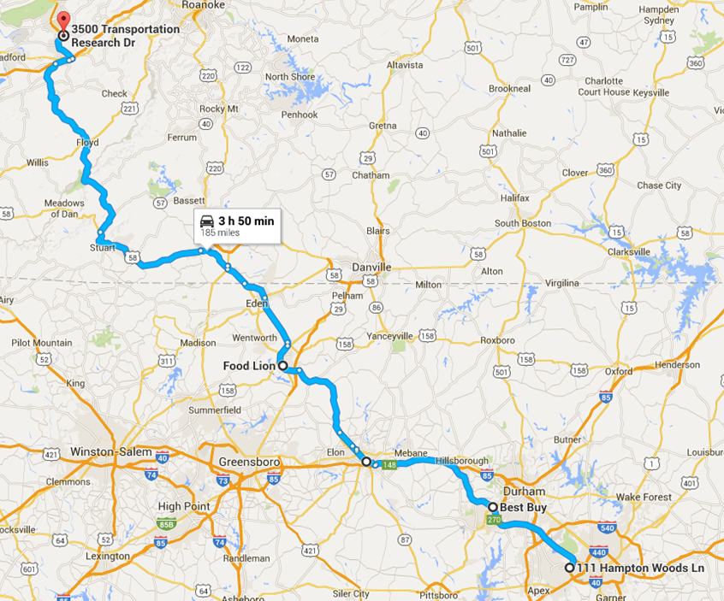

Figure 22: Route Map (Returning Trip on Thursday).